**Title???  
- Climate response of coniferous trees in northern latitudes: longitudinal gradient from west to east**

**- Response of forest ecosystems to climate change beyond the Arctic Circle**

**- Influence of longitudinal climate gradient on larch and pine growth in the Arctic region**

**- Climate response of coniferous trees in the Arctic region: west-east gradient**

**- Regional differences in the climate response of coniferous trees in Arctic climate conditions**

Kristina V. Akulinina1, Alexander V. Kirdyanov1,2, Vladimir V. Kukarskih1,3, Alexey I. Kolmogorov1,4, Victoria V. Agapova1, Alberto Arzac1

1 Siberian Federal University, 79 Svobodnii, Krasnoyarsk 660041, Russia

3 Sukachev Institute of Forest SB RAS, Federal Research Center ‘Krasnoyarsk Science Center SB RAS’, Akademgorodok, Krasnoyarsk, 660036, Russia

3 Institute of Plant and Animal Ecology, Ural Branch, Russian Academy of Sciences,

Yekaterinburg 620144, Russia

4 North-Eastern Federal University, 58 Belinsky str, Yakutsk 677027, Russia

**Abstract**

An increase in temperature in high latitudes will lead to changes in the water balance and thermal regime of permafrost soils, which will affect the structure and functioning of plant communities in northern ecosystems. A method for studying the response of plant communities to environmental and climate changes is dendroclimatic analysis of the radial growth of trees. The article presents the results of such an analysis for the trees *Pinus sylvestris, Larix sibirica, Larix gmelinii and Larix cajanderi*, growing in a zone of continuous permafrost in six areas within the Arctic Circle.

A correlation analysis was carried out between tree ring width indices and climate indicators for the period from 1966 to 2021. The results showed that the main factor limiting the radial growth of trees in all study areas is air temperature, mainly in June and July. Sliding correlations showed that in recent decades there has been an increase in the influence of temperature anomalies on tree growth, especially under conditions of increasing average daily temperature. This indicates potential changes in the structure of plant communities and their adaptation to new climatic conditions. It was also noted that an increase in temperature in the summer months leads to a more pronounced positive dynamics of radial growth, which may be associated with improved photosynthetic processes and increased water availability under conditions of permafrost thawing. In conclusion, the results emphasize the importance of further research aimed at assessing long-term changes in northern ecosystems in response to global warming.

**Keywors:** Arctic, climate change, tree growth, tundra,treeline, permafrost, radial growth

1. **Introduction**

The introduction needs more work. You need to better introduce the topic: Arctic regions are warming faster, and this brings consequences on the ecosystems of the region that may have a global influence as carbon and hydric cycle.

Then you may continue talking about the forest-tundra ecosystem and its potential shifts due to climate change. To then continue with dendrochronology and tree-ring width studies. Here you should provide a brief description of what has been done across northern Russia and Finland.

Finally, it should be described the aim of the work.

In the last decade, an unusual phenomenon has been observed in the Arctic region: unprecedented warming in the forest-tundra ecotone. This climate change has a significant impact on the dynamics of ecosystems in this region. However, the effects of warming are not limited to changes in plant communities. They also affect deep soil processes, influencing the timing of the formation of the active soil layer in areas of continuous permafrost.

In addition to negative effects, rising temperatures can also create favorable conditions for tree growth. Higher temperatures and earlier access to water due to thawing permafrost can contribute to the flourishing of vegetation in the region. Research (Vaganov E.A., Hughes M.K., Kirdyanov A.V., Schweingruber F.H., Silkin P.P., 1999) confirms that all these factors are already affecting the condition of forests and their components. Such changes can have consequences not only for biodiversity, but also for ecosystems in general.

The width of tree rings is directly related to growth conditions, which depend on temperature, precipitation, and other environmental factors. The aim of the work is to assess the climate response of tree radial growth to changes in temperature, precipitation, active soil depth, snow depth, and wood species.

Studying these changes and their possible consequences is becoming increasingly important in the context of global climate change and anthropogenic activities. In addition, changes in forest-tundra ecosystems can serve as indicators of broader climate trends, making their study key to assessing future change scenarios in Arctic regions.

**2.** **Materials and methods**

Since you have different species, I would add a section describing them

*2.1 Study area and sampling*

The research was carried out at six localities along a longitudinal transect above the Arctic Circle, from northeastern Finland to northeastern Russia (27°E to 166°E; Fig. 1A). Four main conifer species in the forest-tundra ecotone were sampled (i.e., *Pinus sylvestris*, *Larix sibirica*, *Larix* *gmelinii* and *Larix cajanderi*). Thus, in the westernmost sites, Finland (hereafter **FIN**) and Apatity in the Kola Peninsula (hereafter **APA**) - *P. sylvestris*. In the central sites, the Polar Urals (hereafter **PUR**) - *L. sibirica* and Khatanga (hereafter **KHA**) - *L.gmelinii*. In the easternmost sites Chokurdakh (hereafter **CHO**) and Bilibino (hereafter **BIL**) *L. cajanderi*. The sites are characterized by harsh climatic conditions that significantly determine the growth and development of tree species. Temperature fluctuations, short growing seasons and low precipitation levels create specific conditions. Thus, over the 1966-2021 period, mean annual air temperature ranges from 0,3 °C in **APA** to -13,1°C in **CHO** (Fig. 1B), and the annual precipitation totals from 558 mm in the **APA** to 210 mm in **BIL** (Fig. 1B). Climate data from the nearest weather station to the sampling sites were obtained from climexp.knmi.nl (Finnish site) [] and www.meteo.ru (Russian sites) [].

The average annual temperature trend for each site shows a general increasing trend (Fig. 1C), as do the temperatures of the combined months (June–September; Fig. 1D). Average number of days per year with temperatures equal to or above 5 °C for the study period 1966–2021 was 133 days and 70 days for the **APA** and **CHO** sections, respectively (Table 1). In addition, there is an increase in the number of days with temperatures equal to or above 5 °C at a variable rate from 44 to 52 days per decade at *P* < 0.01 for the more western and central sites, and 29 days per decade for **CHO** and 11 days for **BIL** (P < 0.01) (Supplement, Fig. 1A).

At each site, a minimum of 20 trees were sampled at breast height with a 5-mm increment borer powered by an electric drill. Tree height and diameter at breast height (dbh) were recorded for the sampled trees (Supplement, Table1).

Since the study areas are located in the Arctic Circle, the soil conditions of each area are affected by permafrost. The depth of seasonal soil thawing (active layer) is greatest in the western regions (FIN, APA), where permafrost is either absent or has an insular character. It can reach 1–2 m. The soils in these areas are podzolic and peat-podzolic, with a fairly high organic content, which contributes to better moisture capacity. In **PUR** and in **KHA**, there is a discontinuous type of permafrost, which is transitional to continuous permafrost, the thickness of the seasonal thawed layer is reduced to 50–100 cm, and the soils are mountain-tundra or tundra-gley. In (CHO) and (BIL), continuous permafrost with a freezing depth of tens of meters is widespread. Here, the active layer is on average 30–60 cm, and the soils (cryozems, tundra-gley) are poor in organic matter and exhibit low microbiological activity. The water regime is largely determined by the speed of snow melting in spring and summer temperatures. In such conditions, soil thawing begins later, but occurs intensively in a short period, which increases the dependence of trees on early summer temperatures.

A 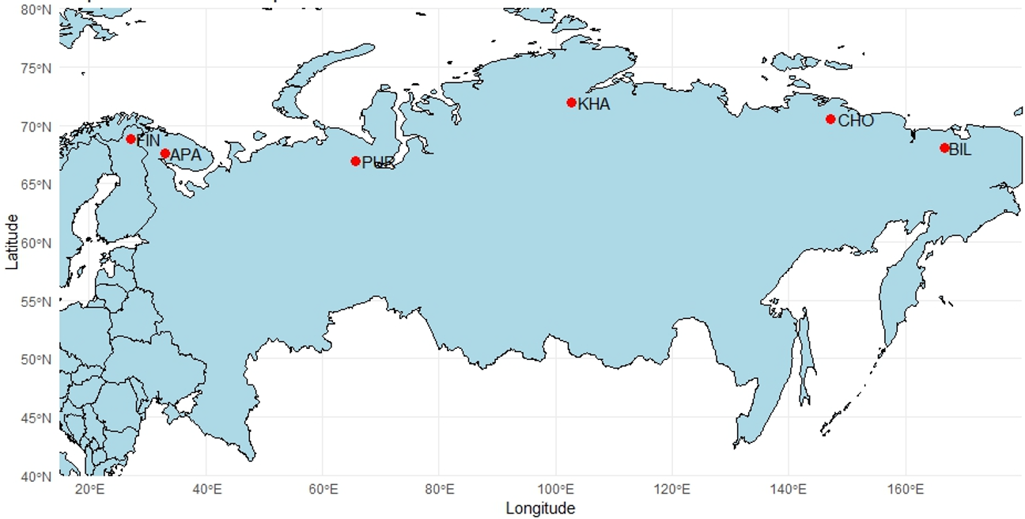

B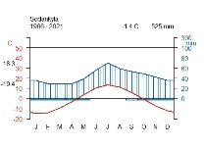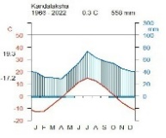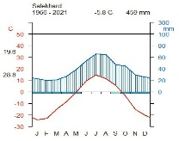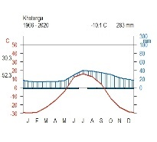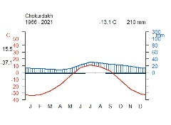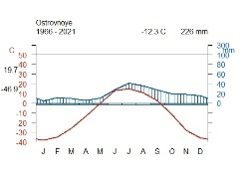

C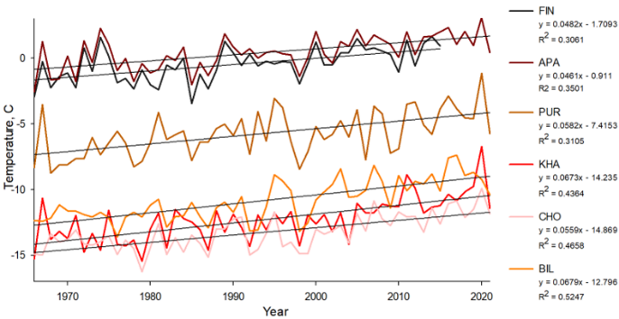 D 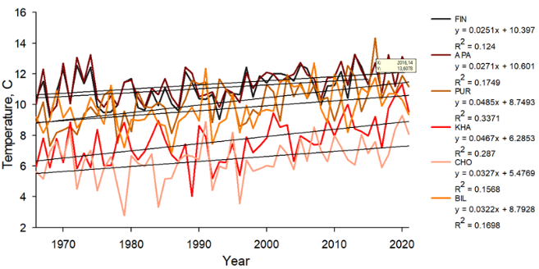

**Figure 1.** Location and climate of the study area: (A) white dots show the location of sampling sites (FIN, Finland, APA, Apatity; PUR, Polar Ural; KHA, Khatanga; CHO, Chokurdakh; BIL, Bilibino). (B) Climate diagram for Sodankyla weather stations, Kandalaksha, Salekhard, Khatanga, Chokurdakh, Ostrovnoye for 1966 – 2021 period. (C) Average annual temperature trends for the periods 1966–2021 in the study areas. (D) Trends in average monthly temperature June-September for the period 1966–2021 in the study areas.

**Table 1** - Characteristics of areas

|  |  |  |  |  |  |  |
| --- | --- | --- | --- | --- | --- | --- |
|  | FIN | APA | PUR | KHA | CHO | BIL |
| Coordinates | 68°77′ N  27°15' E | 67°36' N  33°2' E | 66°54' N  65°45' E | 71°57' N  102°40'E | 70°30' N  147°10' E | 68°02′ N  166°40' E |
| Elevation (masl) | 179 | 127 | 125 | 35 | 7 | 468Начало формы |
| Near weatherstation | Sodankyla  (52 km) | Kandalaksha  (62 km) | Salekhard  (58 km) | Khatanga  (7 km) | Chokurdakh  (2 km) | Ostrovnoye  (48 km) |
| T mean | -0.48 | 0.40 | -5.76 | -12.32 | -13.28 | -10.86 |
| T June-July | 13.09 | 13.05 | 11.90 | 9.43 | 8.31 | 13.05 |
| T June-September | 11.04 | 11.37 | 10.13 | 7.62 | 6.41 | 9.71 |
| P total | 526.56 | 547.48 | 457.21 | 283.10 | 210.40 | 237.10 |
| P June-July | 124.86 | 124.42 | 118.98 | 68.60 | 52.30 | 69.10 |
| P June-September | 235.50 | 242.80 | 229.53 | 141.14 | 104.36 | 131.05 |
| Days  ≥ 5 °C | 121+12,2 | 133+12,2 | 105+13,6 | 82+13,1 | 70+12,7 | 93+11,4 |

The vegetation period is short in all areas (approximately 70 to 130 days). In (FIN) and (APA), the period with temperatures above +5 °C lasts longer, while in (CHO) and (BIL) it may not exceed 70–90 days. Scots pine has permanent needles, allowing it to maintain photosynthesis during periods of sharp “warming” even at the beginning of spring. Larches shed their needles annually, which makes their growth more dependent on the conditions of the current summer. With rapid warming in June, larches get a “starting” advantage if they manage to form needles and begin active growth. However, in cold years, late thawing of the soil can significantly slow down the development of larch.

*2.2 RW measurements and chronologies construction*

The collected cores were subjected to resin extraction using a Soxhlet apparatus with 96% ethanol for 72 hours. After this, wood cores were fixed on wooden supports and polished with a grit up to 1000. An Epson Perfection V800 flatbed scanner (Epson, Japan) was used to scan the polished cores. Tree-ring width (RW) was measured using CooRecoder version 9.3 (Cybis Elektronik & Data AB in Sweden). The wood cores were visually cross-dated and its accuracy was statistically checked with COFECHA (Grissino-Mayer 2001). In the ARSTAN program (Cook E.R., Holmes R.1996), standardization (indexing) of the original time series was performed using a negative exponential or linear function to compensate for age-related changes in ring width. Next, a procedure was carried out to remove the autocorrelation component in order to reduce the influence of non-climatic factors and preserve the high-frequency climate response (Cook E.R., Peters K.,1981). To assess the quality of the obtained chronologies, the following statistical parameters were calculated: sensitivity coefficient (msx), inter-series correlation coefficient (Rbar) and expressed population signal (EPS) (Table 2) (Wigley T.M.L., Briffa K.R., Jones P.D. 1984).

**Table 2** - Chronology characteristics for the period 1966–2021

|  |  |  |  |  |  |  |
| --- | --- | --- | --- | --- | --- | --- |
|  | **FIN** | **APA** | **PUR** | **KHA** | **CHO** | **BIL** |
| msx | 0.25 | 0.25 | 0.40 | 0.55 | 0.44 | 0.44 |
| EPS | 0.65 | 0.89 | 0.96 | 0.96 | 0.97 | 0.96 |
| Rbar | 0.48 | 0.40 | 0.63 | 0.68 | 0.64 | 0.69 |

*2.3 Statistical analysis of climate relationships*

To assess the relationship between tree growth and climate parameters, Pearson correlation analysis was used between tree-ring indices and average monthly temperature and precipitation for the period 1966–2021, from September of the previous year to September of the current year. You also need to mention that the effect of consecutive months was tested.

In addition, daily moving correlations were calculated to assess the peaks of the climate signal over time. This analysis revealed the precise time intervals in which temperature has the greatest influence on wood growth.

To analyze temporal stability, annual moving correlations were used “Treeclim” package (REF) in the R environment (REF),). They assess the stability of the climate signal over time, revealing trends in sensitivity to changes in climate factors.

The analysis of spatial stability of temperature signals assesses the strength, geographic extent, and temporal stability of the relationship between tree-ring width and air temperature (KNMI Climate Explorer (https://climexp.knmi.nl/)

(Беркли 1°)). The resulting correlation maps show the spatial distribution of the temperature signal and its change over time.

**3. Results**

*3.1. Chronologies description*

Correlation analysis between standard chronologies showed significant values for the FIN and APA regions (r = 0.46), where Pinus sylvestris grows, and for the CHO and BIL regions (r = 0.36), where Larix cajanderi grows. No significant values were found for other regions (PUR, KHA), where the main species are Larix sibirica and Larix gmelinii (Supplement, Fig. 3).

The highest positive correlation is observed between the FIN and APA sites (r = 0.59), which is due to similar climatic conditions of the northwestern part of Eurasia and the same wood species (*P. sylvestris*). A moderate positive correlation is also found between the BIL and CHO sites (r = 0.42), which is explained by their geographical proximity and belonging to the same species (*L. cajanderi*).

Sites with different larch species demonstrate weak positive correlations (PUR - KHA, r = 0.25), which may be due to partially similar climatic conditions, but differences in the ecological adaptations of *L. sibirica* and *L. gmelinii.* In contrast, negative correlations are noted between the eastern and western sites (CHO - PUR, r = -0.43; CHO - FIN, r = -0.39), indicating differences in tree responses to climatic factors.

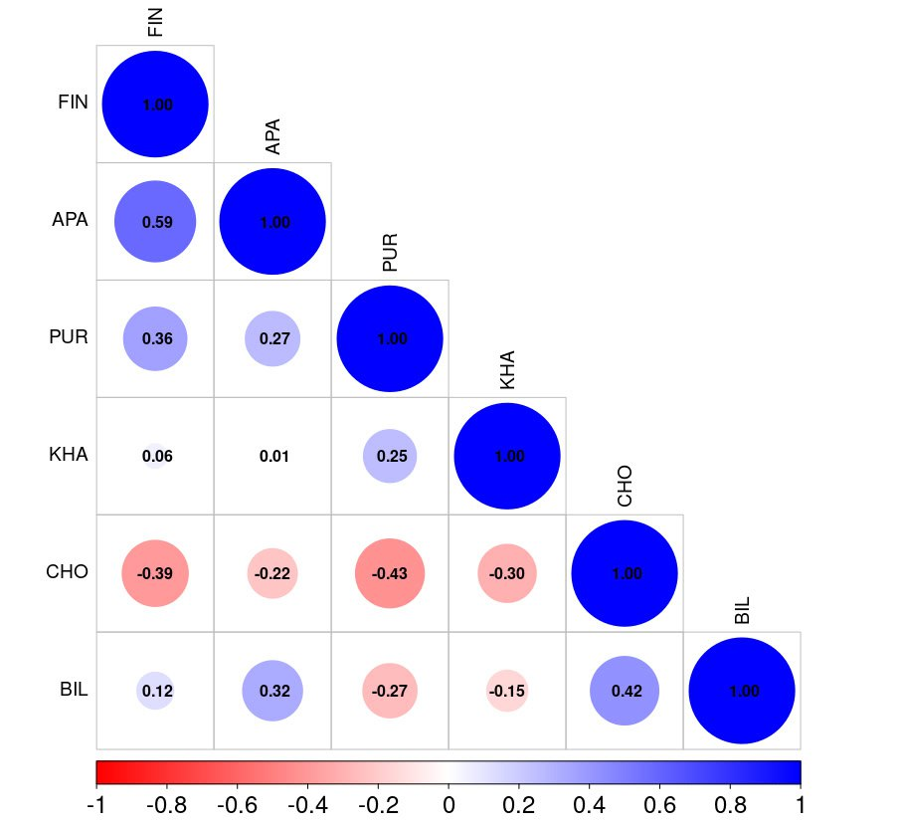

**Figure 2.** Correlation matrix of tree ring widths between study areas

*3.2 Climate-growth analysis*

To assess the relationship between tree radial growth and climatic conditions, a pairwise correlation analysis was performed using Pearson correlation coefficients. The analysis was performed between standard chronologies and average monthly climatic data, including total precipitation and average air temperature. The result between residual chronologies is in Supplement, Fig. 2.

Tree-ring width chronologies showed a positive correlation with summer temperatures (June and July), but the timing and intensity of the climate signal varied between sites. Trees in the PUR, KHA and BIL sites showed an earlier response to June temperature (r = 0.54; r = 0.43; r = 0.41, respectively, at *P* < 0.01), in the CH site r = 0.24 (at *P* < 0.05), indicating temperature limitation of tree growth in a more continental climate. In the western sites (FIN and APA), a significant relationship was found only for July temperature (r = 0.35 and 0.41, respectively, at P < 0.01), which can be explained by milder climatic conditions (Fig. 2A). Temperatures in the previous autumn months, as well as March, had a significant negative effect on the radial growth of trees in the Chokurdakh region (Fig. 2A).

Correlation analysis between chronologies and monthly precipitation showed that precipitation affected radial growth only without a clear pattern for all the study areas. Summer precipitation did not demonstrate a statistically significant effect on radial growth in the considered areas. The most noticeable positive effect of precipitation was found for the APA area in August (r = 0.39, p < 0.01) and in December of the previous year (r = 0.35, p < 0.01) (Fig. 2B). For the easternmost area (BIL), last year's October precipitation had a positive effect (r = 0.41, p < 0.01) and April precipitation had a negative effect (r = -0.37, p < 0.01) (Fig. 2B). In general, no long-term impact of precipitation on the radial growth of trees was detected in any of the study areas.

А 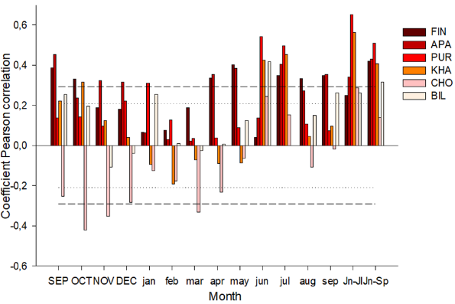B 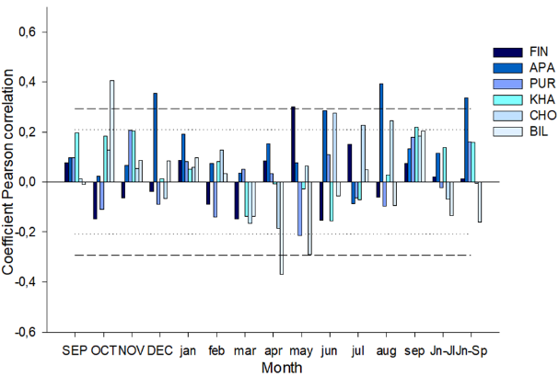

**Figure 2.** Coefficients of paired (A and B) correlations of tree-ring width with temperature and precipitation

Moving daily correlations showed a positive influence of mid-summer temperatures (June 23 – July 10) in all study areas (Fig. 3A). However, when moving from west to east along the northern profile, an increase in the maximum correlation coefficients is noted, as well as their shift to earlier dates. The seasonal dynamics of the influence of temperatures demonstrates a decrease in the significance of July temperatures and an increase in the influence of June temperatures on the variability of tree growth indices. In the western regions (FIN, APA), where Scots pine grows, the effect of July temperatures is weaker (DOY 191 and 190; r = 0.43 and 0.41; p < 0.01) compared to other locations where larch grows: the central sites (PUR, KHA), where the correlation coefficients reach a maximum (DOY 174 and 181; r = 0.65 and 0.67; p < 0.01), and the eastern sites of CHO and BIL (DOY 183 and 176; r = 0.56 and 0.54, respectively; p < 0.01). Analysis of the effect of precipitation did not reveal a significant long-term effect on the radial growth of trees at any of the study sites (Fig. 3A).

A 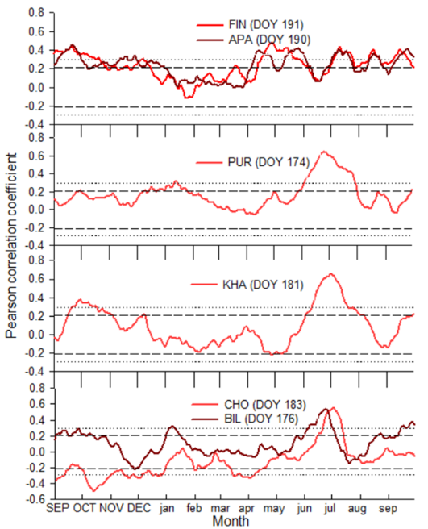 B 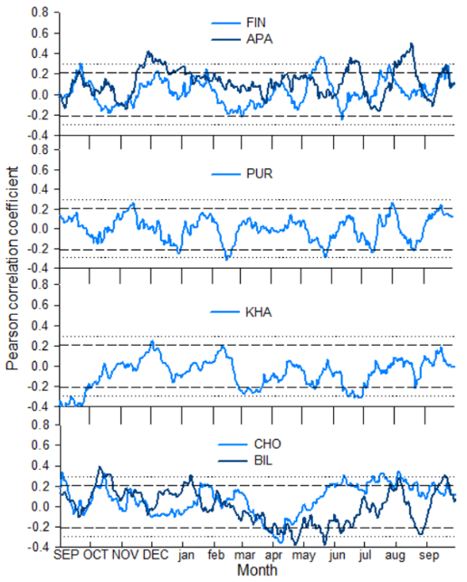

**Figure 3.** Sliding correlation coefficients (A and B) between standard tree-ring width indices and climate data (temperature and precipitation)

*3.2 Temporal stability of temperature signals*

For the moving correlations you should describe that there is instability in the temperature response in most of the sites. That there are changes in the trend occurring at different time periods depending on the site. That some sites show increasing trends whereas other sites show decreasing trends…

The current correlations between the standard chronologies show both positive and negative correlations with temperature for both individual months and aggregated temperatures of several months over the entire period.

A clear increase in correlations with summer temperatures is observed at the western sites (FIN, APA) from the late 1970s to the early 1990s, followed by a slight decrease. In contrast, the PUR, KHA, CHO sites show a general trend of decreasing sensitivity to temperature over time.

The western sites (FIN, APA) show high positive correlations with summer temperatures, especially in July and during the long summer season (June-September).

The central sites (PUR, KHA) show moderate and also time-constant temperature responses, with a noticeable decrease in response strength (especially for the KHA site) in the late 1990s.

The easternmost sites (CHO, BIL) showed different signals over time. For the CHO site, the temperature signal begins to decrease and becomes insignificant around 1980 for all summer months. In contrast, for the Bilibino site, the correlations shifted toward increasing response strength over time (around 1980), showing a higher response to all temperatures except July. The moving correlation analysis highlights the variations in climate sensitivity, indicating that the relationship between temperature and growth has been dynamic over recent decades. The results highlight regional differences in tree growth response to temperature and reveal shifts in climate sensitivity over time.

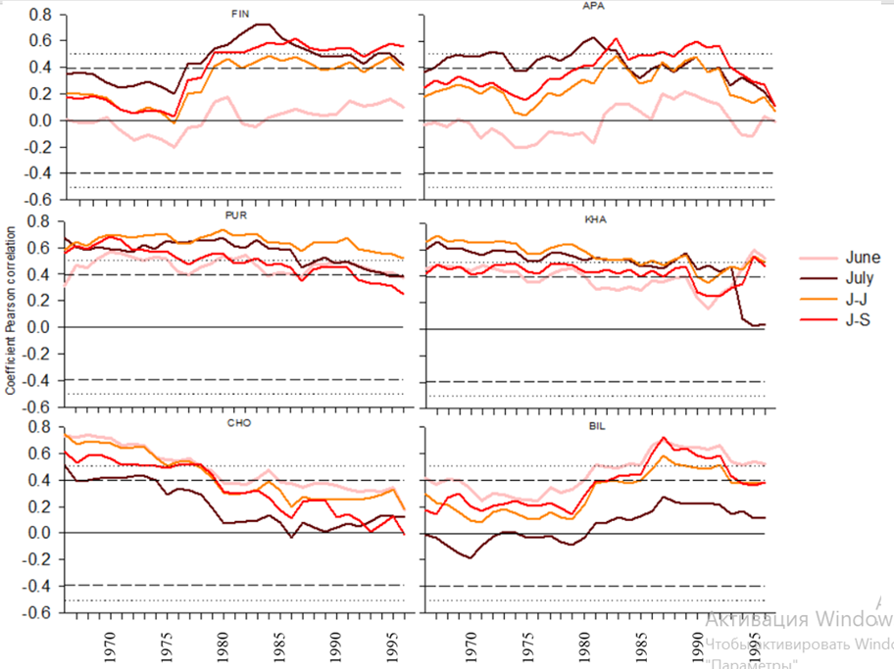

**Figure 4.** Sliding correlations (25-year window with 1-year step) of tree-ring widths with June, July, June-July, June-September temperatures for the total period 1966–2021

*3.3 Spatial stability of temperature signals*

In Figure 5, the spatial stability of temperature signals for the western sites (FIN, APA) showed very weak correlations, especially in June. The strongest relationships are observed in July (r = 0.4) and the long summer period (JUN-SEP) (r = 0.4), suggesting an effect of accumulated summer heat on radial growth.

The central sites (PUR, KHA) show strong and spatially extensive correlations, especially for the aggregated temperatures of June–July (r = 0.6 and 0.5, respectively). These sites also have high correlations (r = 0.5) with the temperatures of individual months: June for PUR and July for KHA. PUR shows the most pronounced response of high positive correlation compared to the other sites. Compared to the neighboring site, KHA shows a more localized, but still significant correlation, emphasizing the strong temperature sensitivity of *L. gmelinii.*

CHO and BIL show generally weaker and more spatially restricted temperature signals compared to the central and western regions. The highest correlations are observed in June–July (r = 0.3) and June–September (r = 0.3), suggesting that prolonged summer temperatures play a more important role in these less favourable conditions.



|  |  |  |  |  |
| --- | --- | --- | --- | --- |
|  | JUN | JUL | JUN- JUL | JUN-SEP |
| FIN |  |  |  |  |
| APA |  |  |  |  |
| PUR |  |  |  |  |
| KHA |  |  |  |  |
| CHO |  |  |  |  |
| BIL |  |  |  |  |



**Figure 5.** Spatial field correlations between June, July, June–July and June–September mean temperatures (Berkeley 1°) and tree-ring widths for the period 1966–2001. Black dots indicate the locations of sampling sites.

snow depth ?

standart chr

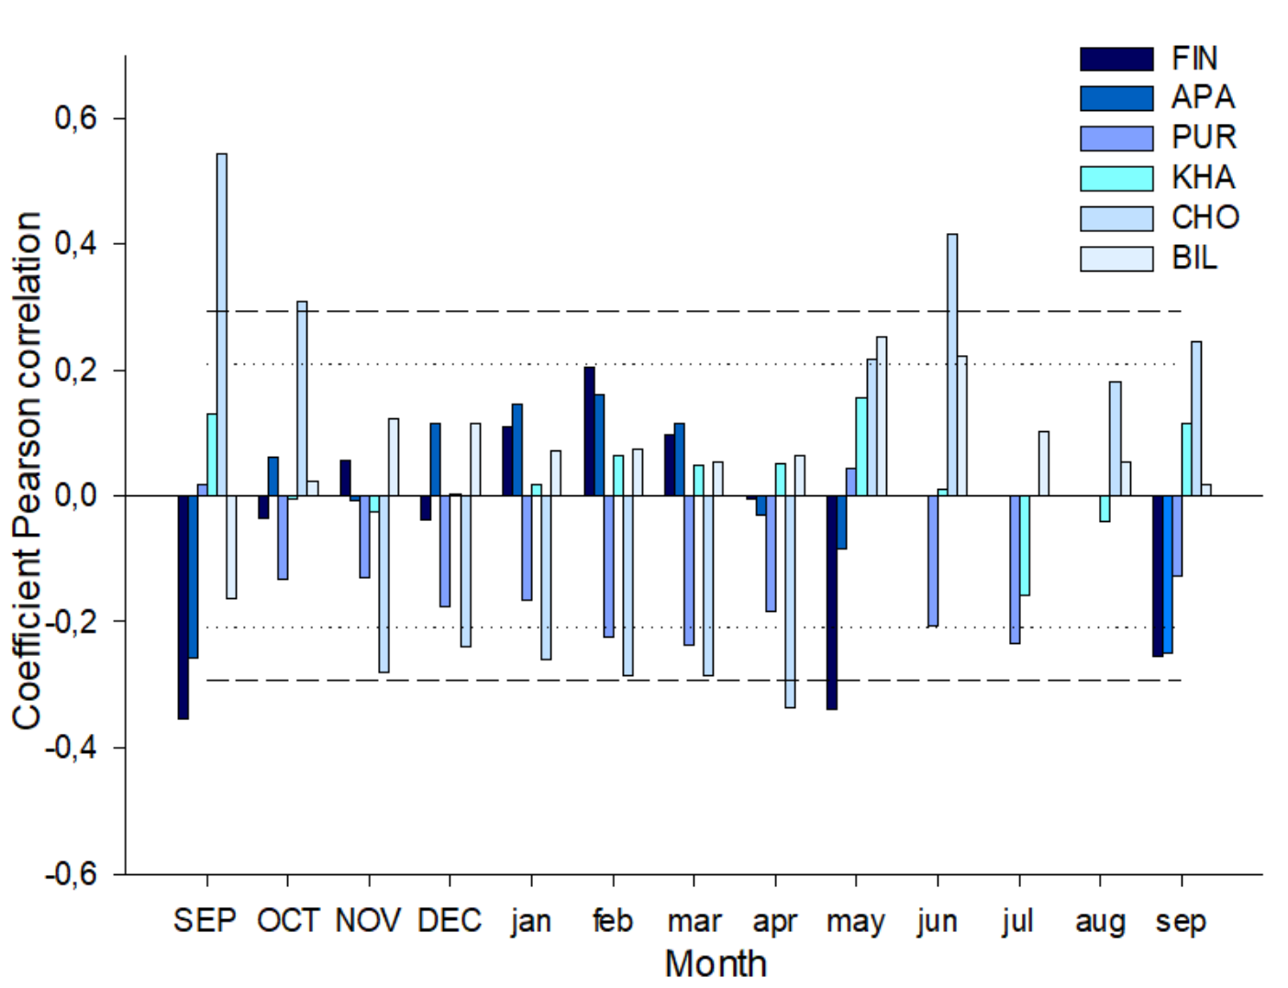

Residual chr

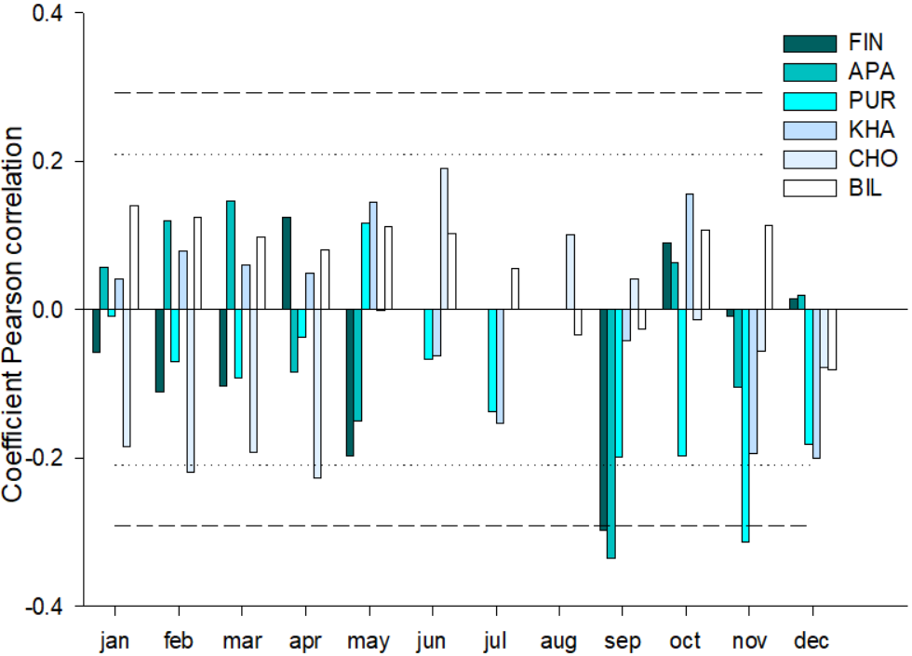

**Discussion**

Here you should provide a first paragraph summarizing your results.

Then you can discuss the temperature and precipitation responses, first monthly and then daily. Why sites respond at different timing, why some are more sensitive than others.

Then you should discuss the moving correlations, why the signals are so inestable, why some sites show increasing sensitivity despite of the warming trends.

The radial growth of trees in northern latitudes depends significantly on the temperature of the summer months (primarily June and July). This effect is expressed in regional features of the response of trees to climatic signals. The longitudinal gradient of the response to thermal conditions is manifested in the fact that in the western areas (FIN, APA), where permafrost is either absent or fragmentary (island-like), July temperatures have a more significant effect on tree growth. Here, the growing season begins later, and the peak of active growth of the annual ring occurs in mid-summer. Increased precipitation compared to more eastern areas and a greater thickness of the active soil layer also increase the availability of moisture and nutrients. In the central (PUR, KHA) and eastern (CHO, BIL) areas with a harsher climate and continuous permafrost, June is the most significant, which can be explained by the earlier onset of growth upon reaching the temperature threshold for photosynthesis and the formation of new needles. At the same time, the limited thickness of the active soil layer and the low nutrient content require the most efficient use of the short warm window in the summer season, so the trees are highly sensitive to June temperatures.

Despite the general tendency towards greater dependence on temperature, in some areas a weak but statistically significant effect of precipitation was revealed (in Apatity and Bilibino in certain months). These differences may be associated with local soil characteristics, as well as the timing and intensity of rainfall. In areas with continuous permafrost, heavy precipitation in the first half of summer may not have time to penetrate into the deep soil layers due to a weakly thawed layer, or vice versa - with intensive surface runoff, plants receive less water. ???

*Pinus sylvestris*, having permanent needles, is capable of starting photosynthetic activity earlier under relatively favorable conditions. However, in warmer western regions (FIN, APA), this advantage is partially offset by the climate, where the decisive factor is the peak of summer temperatures. Larches in conditions of continuous permafrost are forced to quickly "unfold" at the beginning of summer: form needles, carry out photosynthesis and lay down growth. Therefore, June temperatures are the most critical. Higher temperatures at the beginning of summer lead to a better initial growth phase, which is reflected in an increase in the width of annual rings.

**Conclusion**

The results of the study showed that the influence of climatic factors on the radial growth of trees along the longitudinal gradient in northern latitudes is diverse and depends on the regional characteristics of the territory.

The main climatic factor determining the radial growth of trees in the study areas is the temperature of the summer months. Precipitation did not have a significant impact. Pine and larch demonstrate different adaptation strategies to harsh conditions.

**Acknowledgments**

This work was carried out with the support of the Ministry of Science and Higher Education of the Russian Federation [FSRZ-2020-0014].

**Supplements**

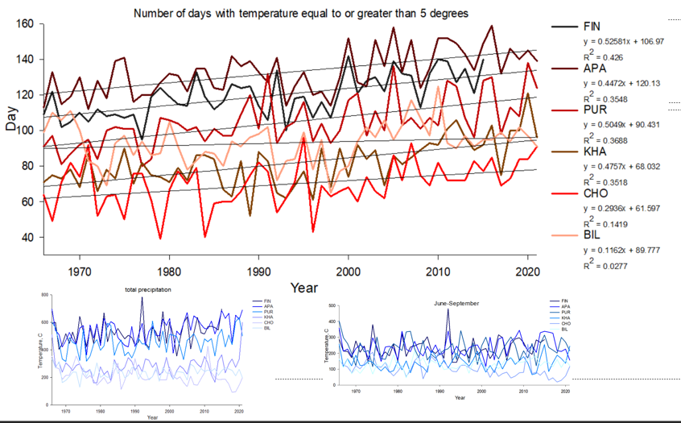

**Figure 1.** Number of days with temperature equal to or above 5 °CА 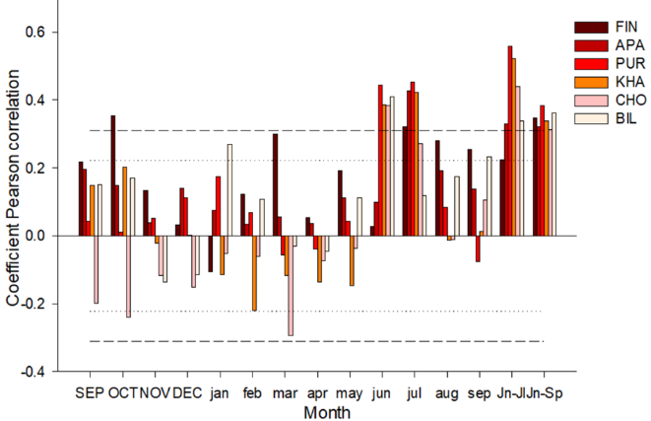 B 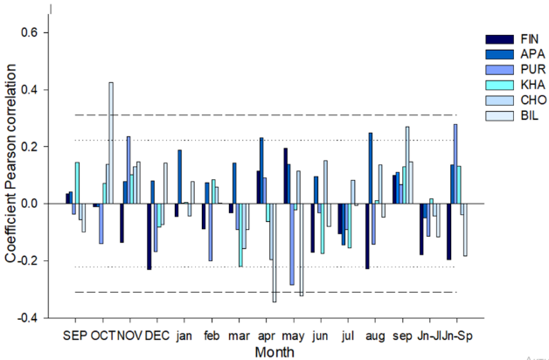

**Figure 2.** Coefficients of paired (A and B) correlations of tree-ring width with temperature and precipitation

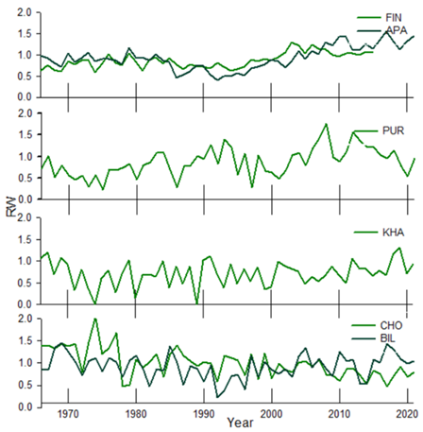

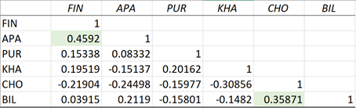?

**Figure 3.** Tree-ring width indices for the period 1966 to 2021

**Table 1** - Characteristics of trees

|  |  |  |  |  |  |  |
| --- | --- | --- | --- | --- | --- | --- |
|  | **FIN** | **APA** | **PUR** | **KHA** | **CHO** | **BIL** |
| Number of trees | 35 | 18 | 26 | 18 | 20 | 20 |
| Average age of trees (years) | 162 ±59,4 | 263 ±73,6 | 133±35,9 | 300±36,7 | 331,35±118 | 163±22 |
| Mean dbh (cm) |  | 36.6 | 15.3 | 22.3 | 13.7 | 16.9 |
| Mean tree height (m) |  | 14.5 | 9 | 11.7 | 5.4 | 9.12 |
| Average tree ring width (mm) | 0,98+0,12 | 0,98+0,14 | 0,95+0,3 | 0,95+0,29 | 0,98+0,29 | 0,98+0,11 |
| Active soil layer deep (cm) | ? | ? | ? |  | 14 | ? |